 Gate **Cheshire Smallholders Autumn 2017**

**Chairman’s Chat**

Autumn arrives and we have been busy organising the next series of Reaseheath lectures and site visits for members, please do take a look at the updated website at [www.cheshiresmallholders.org.uk](http://www.cheshiresmallholders.org.uk) to see the outrun.

Over the summer we attended both the Cheshire and the Nantwich shows, meeting many old and new faces. Thanks particularly to Steve Williams, Kevin Holmes and Neil Holding for helping out on the stands.

This summer we managed to arrange an additional site visit to John Bebbington’s allotment in June, as well as the excellent trip to the South Cheshire Barn Owl Trust in Audlem in May.

Since the last Gate, Defra have updated their guidance on Avian Influenza with a new web update uploaded on 1st September 2017. The advice we received earlier in the year is that as a disease spread by wild and migratory birds, there is a strong possibility that bird flu will return to the UK this winter, with the likely restrictions that entails.

Good luck with your Autumn projects and your preparations for Winter, we look forward to seeing you at the first of our 2017 – 2018 Reaseheath lectures on Monday 25th September.

David Golding, Chairman

**Committee**

Lawrence Beard (Treasurer & Membership Secretary) 01625 572324

Andrew Davies 07939 629474

Arthur Green (President) 01270 841288

David Golding (Chairman & Web Editor) 01270 528790

Rosie Golding 01270 528790

Neil Holding 01928 789800

Kevin Holmes 01928 722365

Gill Lawson (Secretary)

If you would like to get involved in the committee and can spare an hour or so each month please contact David.

No specialist skills are required, first and foremost we allocate tasks to people that they will enjoy doing.

**Upcoming CSA Reaseheath meetings**

A full listing of our monthly speakers and site visits has been updated on the website at [www.cheshiresmallholders.org.uk](http://www.cheshiresmallholders.org.uk).

We have made provisional bookings for nearly all of next year and details of each talk can be found there. Our next lecture is on Monday 25th September and will be on Alpaca keeping.

Dates until Christmas are as follows:-

**Monday 25th September 2017**

**Monday 30th October 2017** – Lecture and AGM

The AGM this year will be held on Monday 30th October 2017, if you have a topic you would like to include in the AGM agenda, please contact one of the committee member.

**Monday 27th November 201**7

**December** – no meeting

If you would like to suggest a lecture topic and / or speaker please contact us at info[@cheshiresmallholders.org.uk](mailto:admin@cheshiresmallholders.org.uk) . We are always interested in hearing from our members and finding out what interests them.

Reaseheath meetings doors open **7.30pm for 8pm** start, come early, have a cup of tea or coffee and a chat. Find us at: Room L3, The Leverhulme Centre, Reaseheath College, Nantwich, Cheshire, CW5 6DF. The Leverhulme Centre is on the right (from the B5074 entrance) just before the car park barrier.

**Spotted an Old Spot?**

The Gloucester Old spot pig or the “Orchard Pig” is one of the best known of all the pig breeds with its distinctive black spots and large lop ears. However, this iconic pig could face extinction if the dramatic decline in numbers continues. The Rare Breeds Survival Trust have again placed it in the “At risk” category on their watch list; in 2014 there were 837 sows producing birth-notified litters but by 2016 this had dropped to just 416 sows.

There is a need to preserve our native breeds to stop the genetic pool from shrinking; as production systems change and diseases evolve it is the genes in the traditional native pigs that may help protect future generations of commercial pigs.

Taste is the key selling point for native breed meat products and food experts acknowledge that different breeds have different cooking and eating qualities. People need to buy pedigree native breed pork and when they buy make sure that they are only buying the real thing. Many people claim to have eaten Gloucester

Old Spot sausages but with so few sows in the country the chances are this is not from pedigree stock and therefore is doing little to preserve the breed.

For smallholders the message is clear - when thinking about keeping pigs consider breeding pedigree and help to preserve our native breeds for generations to come.

More information on Gloucester Old Spot pigs can be found on the British Pig

Association website or from the Rare Breeds Survival Trust.

RBST watch list for pigs 2017 - 2018

1. Critical – no pigs are currently classed as critical.
2. Endangered (100 to 200) – British Landrace, British Lop, Large Black, Middle White.
3. Vulnerable (200 to 300) – Berkshire, Large White, Tamworth.
4. At Risk (300 to 500) – British Saddleback, Gloucestershire Old Spot, Welsh, Oxford Sandy and Black.

**All the leaves are brown**

There are two separate dates which could be said to mark the start of autumn in calendars, one is defined by the Earth's axis and orbit around the sun and the second is a fixed date which is used by meteorologists for consistent spacing and lengths of the seasons.

Meteorological autumn begins on 01 September 2017 and ends on 30 November 2017; the meteorological seasons consist of splitting the year into four periods made up of three months each. These seasons are split to coincide with the Gregorian calendar, making it easier for meteorological observing and forecasting to compare seasonal and monthly statistics.

Astronomical autumn begins on 22 September 2017 and ends on 21st December 2017, the astronomical calendar determines the seasons due to the 23.5 degree tilt of the Earth's rotational axis in relation to its orbit around the sun. Both the equinoxes and the solstices are related to the Earth's orbit around the sun and they are considered to be the astronomical transition points between the seasons.

The dates of equinoxes and solstices aren't fixed, due to the Earth's elliptical orbit of the sun - the path of the Earth around the Sun is not a perfect circle, it is slightly oval-shaped. In early January the Earth is closest to the Sun at perihelion, while in early July it is at its furthest at a time known as aphelion. The variation in distance between Earth and Sun at perihelion and aphelion is approximately 3%.

The perihelion in January does, as you would expect, make the southern hemisphere a little hotter than the northern hemisphere summer as the Earth is closest to the sun at this time, but the southern hemisphere summer is shorter, as the closer the Earth is to the Sun the faster it moves. The perihelion will not always occur in January, there are year to year fluctuations, but on average, perihelion occurs a day later every 58 years due to "precession".

If we wait for about 10,000 years, perihelion will occur during the northern summer, then it will be the turn of the people of Cheshire to cope with slightly hotter and shorter summers. Please don't all rush out just yet to buy the factor 30 lotion in the summer sales this year give it another 9999 years before stocking up.

How about a white Christmas instead?

**Site visit May 2017 – South Cheshire Barn Owl Trust**

We were very fortunate to tour Roger and Margaret Smith’s wood and “Millennium” wood in May, with David Bromont from the South Cheshire Barn Owl Trust. Although we didn’t see any Barn Owls, we were treated to an insight into how the woodland project has grown and developed over the years and a superb supper prepared by Margaret.

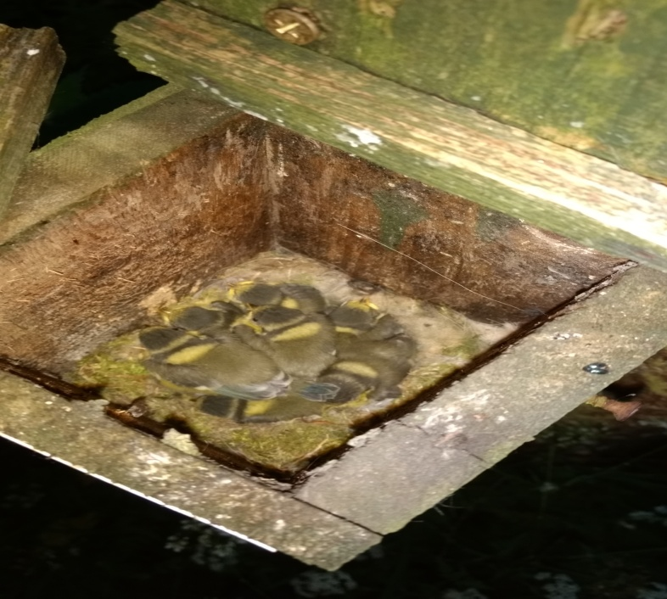

Of particular interest was the smaller bird boxes, in one of which we saw some blue tits chicks. One of Britain’s most common birds, with an estimated 3.3m breeding pairs, the female lays 7-13 eggs in April – May that are incubated for up to 16 days.

The male feeds the female while she is brooding and both feed the chicks when they hatch.

Chicks fledge after 19 days.

**Avian Influenza updates**

From Defra website - 5th September 2017 – “There are no Surveillance Zone or Protection Zone controls in place at the moment.”

Latest information available at :-

https://www.gov.uk/guidance/avian-influenza-bird-flu

There is an option to sign up for alerts on this page.

**Farming Advice Service - Free and confidential advice**

Common Agricultural Policy (CAP) regulations require European Union (EU) Member States to run an advisory system covering cross compliance, greening, water protection and aspects of pesticide use. In England, this is provided by FAS. Under these regulations, the advice given to individual farmers must be confidential – that is, FAS must not disclose any personal or individual information or data it obtains in the course of its advisory activity.

FAS updates the farming sector on relevant EU and Department for Environment, Food and Rural Affairs (Defra) policies. It explains the requirements under and objectives of CAP, EU directives, national legislation and policies; and the actions that can be taken to help meet compliance.

FAS provides free, confidential advice on cross compliance and the greening requirements, some aspects of the Water Framework Directive (such as silage, slurry and agricultural fuel oil (SSAFO) and waste exemptions) and the Sustainable Use (of pesticides) Directive. Getting in contact with the advice line Farmers requiring telephone advice from FAS can contact the Rural Services Helpline on 03000 200 301 Monday to Friday between 8.30am and 5pm.

The Rural Services Helpline provides a single number for all FAS, Rural Payments Agency, Animal and Plant Health Agency, Natural England and Forestry enquiries. By providing a single point of contact, the Government aims to make it simpler for farmers to access technical guidance on a range of topics, including cross compliance, greening, CAP payments and animal health inspections.

You can also email enquiries to [advice@farmingadviceservice.org.uk](mailto:advice@farmingadviceservice.org.uk).

**Public rights of way requirements**

Many farmers / smallholders have land with a public right of way (PROW). These fall into the following categories:

• footpaths;

• bridleways;

• restricted byways;

• byways open to all traffic (BOATs).

If you own agricultural land with a PROW, there are several rules you need to be aware of. Below are a few of the key rules you need to comply with. Full guidance is available on GOV.UK

**Keep PROWs on your land clear free of obstructions**

As the owner or occupier of land with a PROW, you have an obligation to keep the route visible and clear of obstructions. Obstructing a PROW intentionally is a criminal offence and the highway authority has the right to demand that you remove any obstructions. In practice, this means removing and preventing obstructions on or across the PROW route, such as permanent or temporary fences, animal feeders, hedgerows growing over the path, padlocked gates, encroaching crops (other than grass) and barbed wire.

Make sure that vegetation does not encroach onto the route from the sides or above while considering the height clearance required for different users, such as horse riders.

**Maintain or replace structures in accordance with guidance**

Where stiles and gates on a PROW are your responsibility, you must maintain them in a condition that makes them safe and reasonably easy to use. You can claim 25% or sometimes more of the cost of any replacement work from the highway authority. Some authorities provide materials; others may carry out the work themselves.

Where a stile needs replacing, always consider with the highway authority whether this should be replaced with a gap or a gate. In most cases, a gap will be preferred as it will provide easier access for people with mobility problems, such as the elderly, pregnant women and young children. Gaps and gates also require less maintenance than stiles so you can save costs.

If you are considering adding a new structure on a PROW, then you must seek authorisation from the local highway authority. Unauthorised structures will be classed as obstructions and may be removed by the highway authority at your expense. Similarly, if you add new ditches or widen existing ones, you must secure the necessary permissions (including from the highway authority) and provide adequate bridges for PROW users.

Both articles above from FAS newsletter – sign up to receive a copy direct on their website.

**Bowl me over!**

In October 2017 we would still like to host a food and skittles evening at the Bickerton Poacher. We need a minimum of about 16 people to participate, if you are interested, please contact any of the committee members in advance so we can get an idea of numbers.

http://www.bickertonpoacher.com/php/skittles.php

**Whole Lotta Love (ly) cheese**

A group of barber dodgers below, seen at the Nantwich Show in July. If you would like to help on the CSA stand next year, with plenty of free time to peruse the largest cheese festival in the world, please speak to one of the committee members between now and then - tell them you haired it on the grapevine.

From left to right, Kevin Holmes, Steve Williams and David Golding.

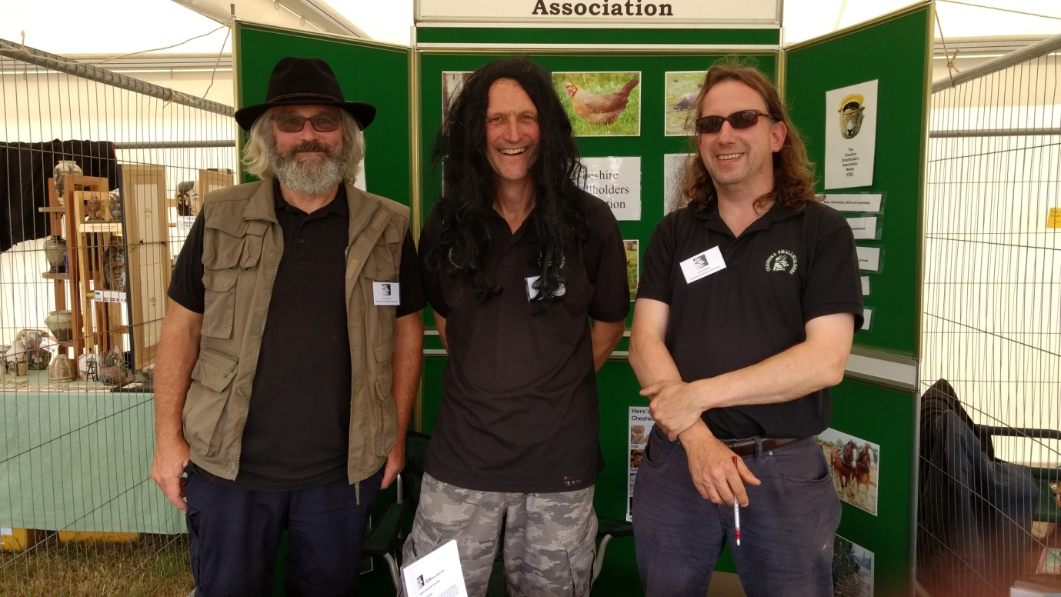

**Membership subscriptions**

Subscriptions were due for 2017 / 2018 on 1st September 2017 and we are keeping the annual subscription at £15; to put it another way, just £1.25 a month, which covers your whole household.

To make life easier, please consider paying by standing order, a form can be downloaded from the membership page on the website, [www.cheshiresmallholders.org.uk](http://www.cheshiresmallholders.org.uk).

For further details, email [members@cheshiresmallholders.org.uk](mailto:members@cheshiresmallholders.org.uk) or telephone Lawrence, your Treasurer and Membership Secretary, on 01625 572324.

**Laughter line**

Two scarecrows were overheard talking to each other over a hedge. “I’m outstanding in my field” said Worzel to Gummidge. Gummidge replied, “Yes my friend, you are, this job isn’t for everyone. I’m a natural though; hay, it’s in my jeans.”

**Coming up soon**

**September 2017**

Annual Show & Sale of Pedigree Rare & Traditional Breeds

Beeston Agricultural Centre, 23rd September 2017.

www.wrightmarshall.co.uk/

Yarndale

Skipton Auction, Skipton, BD23 1UD, Saturday 23rd and Sunday 24th September 2017

www.yarndale.co.uk

Cheshire Ploughing and Hedge laying Match

Woods Tenement Farm, Pinfold Lane, Plumley WA16 0TW

Wednesday 27th September 2017

www.cheshireploughing.co.uk

**December 2017**

Father Christmas at the Farm, Tatton Park, Knutsford

**Please note, due to the weather, it has been reported by the elves that there has been a bumper crop of goodness this year, such that he and the grown ups may try and trim the list of children getting presents on mischief night (30th October).**

**Rosie has told me that unless I pick up last year’s socks from the bedroom floor, I won’t be getting any more this year.**

www.tattonpark.org.uk

Always check with the organisers before making arrangements or travelling, shows are sometimes cancelled, often at the last minute!

**Charity Appeal**

David Golding is planning to trek to Kala Pattar and Everest Base Camp in April 2018. If any CSA members would like to support David, he has suggested members might like to donate to our nominated Charity, which, for many years, has been Send a Cow.

Send a Cow provide direct support to African farmers and you can either donate via our Treasurer, Lawrence, or the Send a Cow website, [www.sendacow.org](http://www.sendacow.org)

**Adverts**

**Pedigree registered Texel shearling tups for sale** - Signet recorded, in top decile / quartile for breed in the country. Heptavac / Orf vaccinated, Crovect treated and wormed. Prime condition, ready to work this breeding season.

Price on application, contact Diane or John Mifflin on 01782720572 or 07966979469. Any inspection welcome.

**Beulah yearlings (Chester area) -** Heptavac treated, open to offers, please contact Rob on 07958 647045.

**Chick brood box for sale -** Home made chick brood box. Sturdy, with heat lamp. Offers welcome, call Kevin for more details 07773780722.

**Mr Clip Shearing -** Small and large numbers catered for by "Mr Clip" himself, Cecil. Very experienced with both sheep and alpacas. Reasonable rates, based Knutsford. Call on 07779081925 or 07503 777585.

**Lincoln Longwool fleece for sale -** 12 - 15lb in weight, £20. Phone Angela on 07786 620076 for more details.

**Small bales of hay (2016)** - Lovely; weed free, home grown & barn stored. £3.50 a bale, Kingsley area, may be able to deliver. Contact Gill. 07933 767994.

**Logs for sale** - Barn dried and stored, small net bags, builders’ bags or trailer loads. Free local delivery also **Hay & straw** - In small bales or large round bales. Good quality and dry. Call Mike on 0771 476 8164 or Chris on 0787 102 4275. Helsby area.

**Rotovator wanted** - Ideally a Howard gem or similar. Please call Rosie on 07770 783980.

Members may advertise on the website and also in "The Gate", please email your advert to editor@cheshiresmallholders.org.uk

Please mention Cheshire Smallholders Association when replying to advertisements.